Unit 7: Testing, Maintenance, and Documentation
Digital Management and Communication System for Small Homeowners Associations
Darryl Del Rio
University of the People
MSIT 5910-01 Capstone Project- AY2027-T1
Dr. P. G. K. Sirisha
Oct 21, 2026

Part A: System Testing and Documentation
1. System Testing
This section presents the results of integration, system, and acceptance testing performed on the HOA Digital Management System. Testing focused on the modules implemented in Units 4–6: authentication, role-based access, document upload, document validation, document versioning, and document listing. Each test case includes the Scenario, Expected Result, Actual Result, Pass/Fail status, and supporting screenshots.
Test Case 0.1 — Invalid Login Attempt (Wrong Credentials) 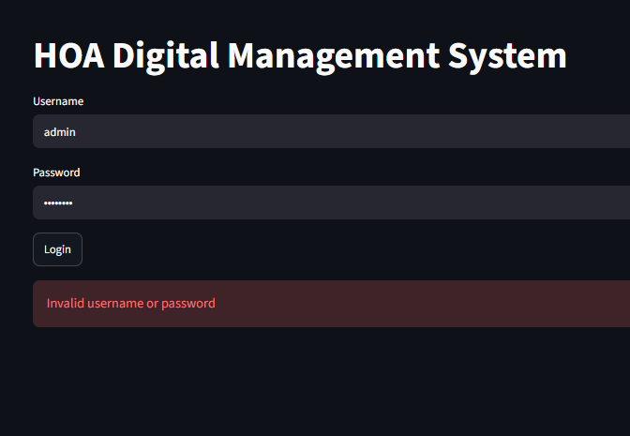
Scenario: User enters an incorrect username or password.
Expected Result: System rejects login and displays an error message.
Actual Result: Error message displayed; access denied.
Status: PASS
Test Case 0.2 — Missing Required Fields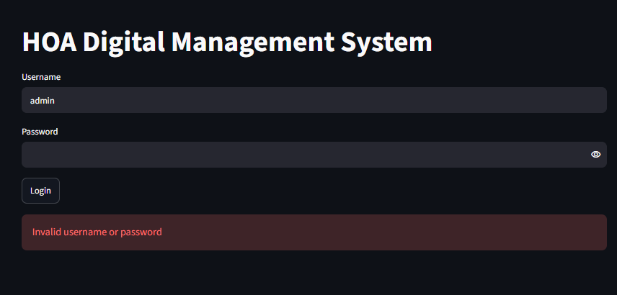
Scenario: User submits login form without entering username or password.
Expected Result: System displays validation message and prevents login.
Actual Result: Validation message displayed; login blocked.
Status: PASS
Test Case 0.3 — Successful Login (Admin Role) 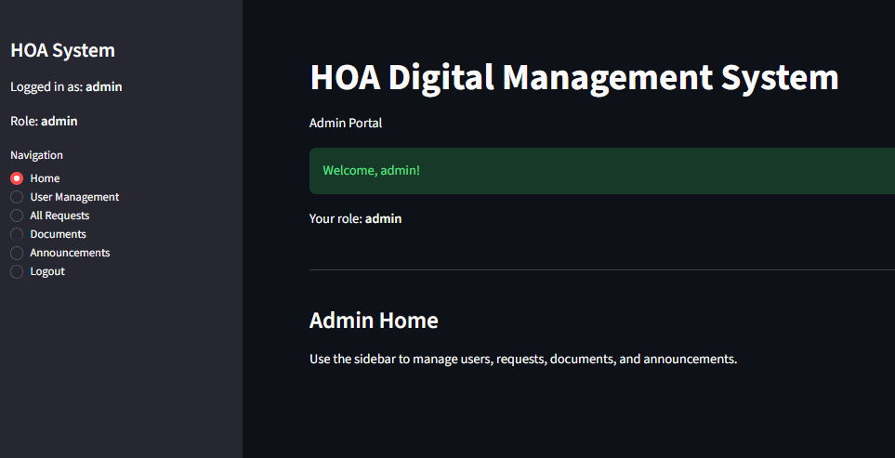
Scenario: Admin enters valid credentials.
Expected Result: System authenticates user and loads Admin Portal with correct role.
Actual Result: Admin Portal displayed; role shown as “admin.”
Status: PASS
Test Case 0.4 — Successful Login (Resident Role) 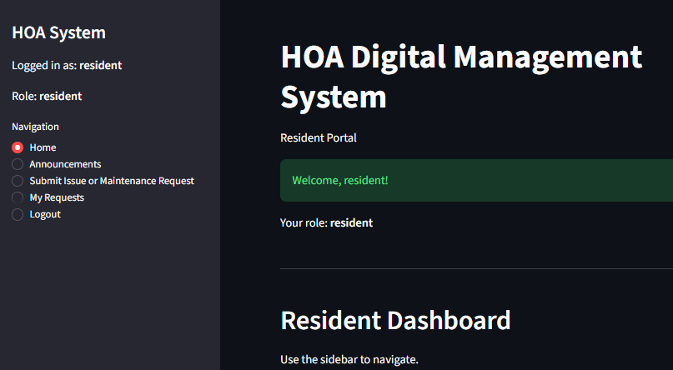
Scenario: Resident enters valid credentials.
Expected Result: System authenticates user and loads Resident Portal.
Actual Result: Resident Portal displayed with correct navigation options.
Status: PASS
Test Case 0.5 — Successful Login (Board Role) 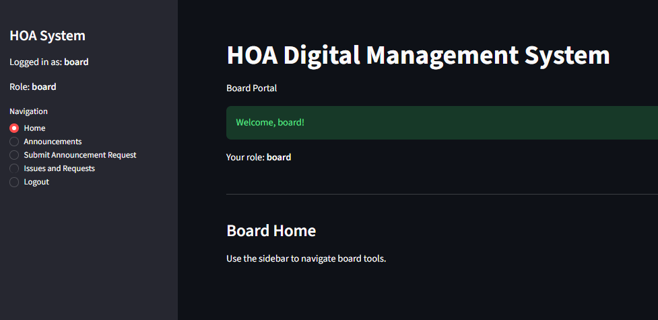
Scenario: Resident enters valid credentials.
Expected Result: System authenticates user and loads Board Portal.
Actual Result: Board Portal displayed with correct navigation options.
Status: PASS

Test Case 1 — Valid Document Upload (.docx / .pdf) 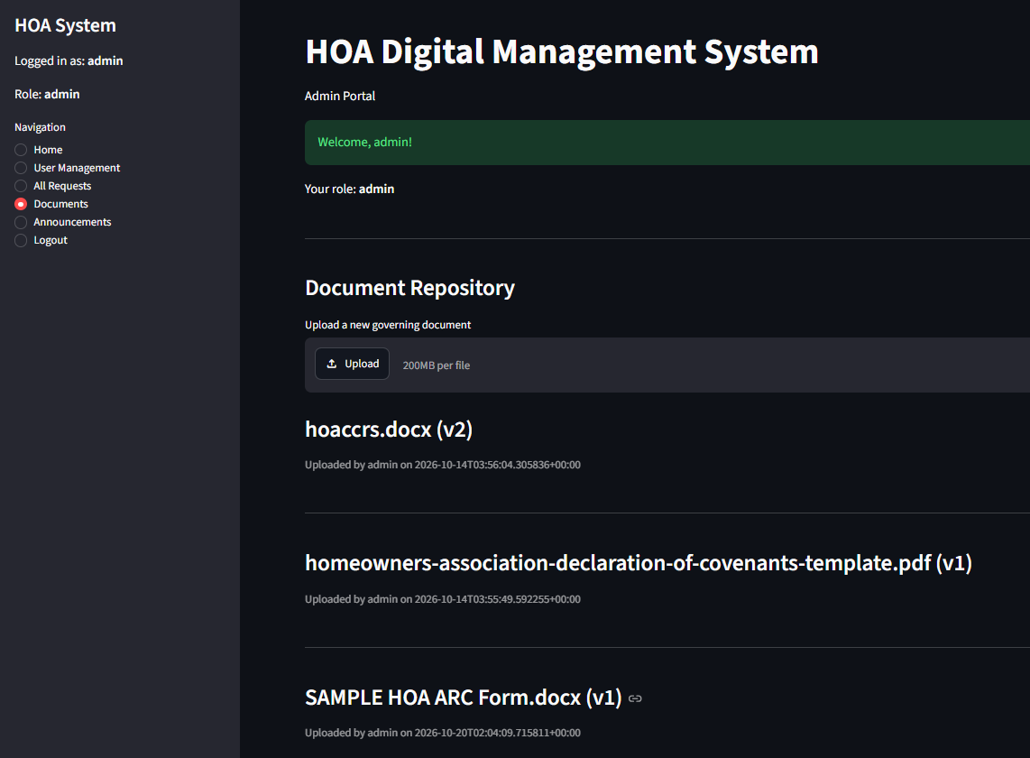
Scenario: Admin uploads a valid governing document.
Expected Result: System accepts file, stores it, and displays confirmation.
Actual Result: Document uploaded successfully; confirmation displayed.
Status: PASS
Test Case 2 — Invalid Document Upload (.txt) 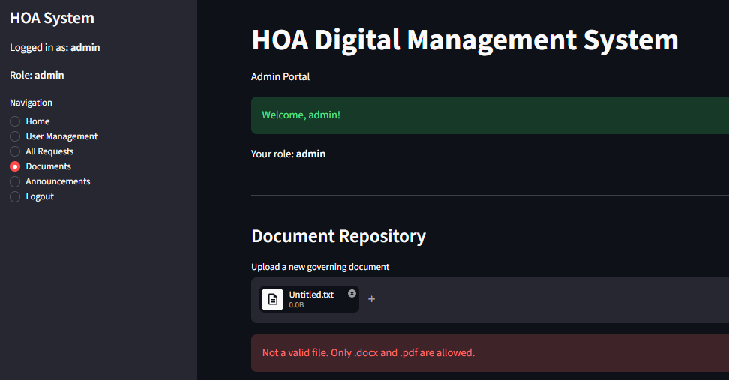
Scenario: Admin attempts to upload an unsupported file type.
Expected Result: System rejects file and displays error message.
Actual Result: Error message displayed; upload blocked.
Status: PASS
Test Case 2.2 — Clearing an Invalid File Selection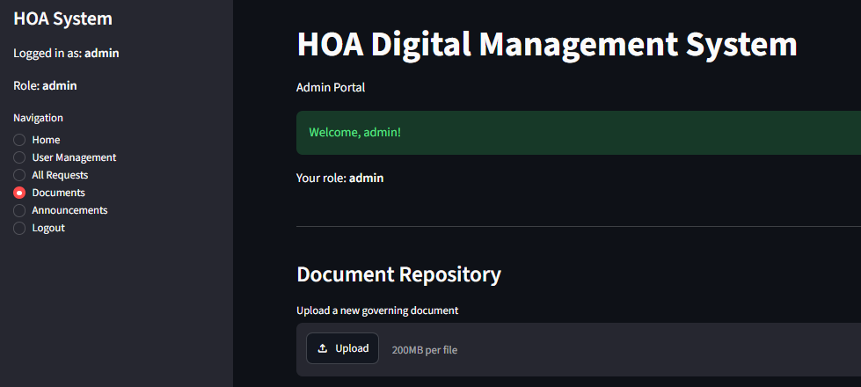
Scenario: Admin clears invalid file selection.
Expected Result: Uploader resets to default state.
Actual Result: Uploader cleared; no error message displayed.
Status: PASS
Test Case 3 — Oversized File Handling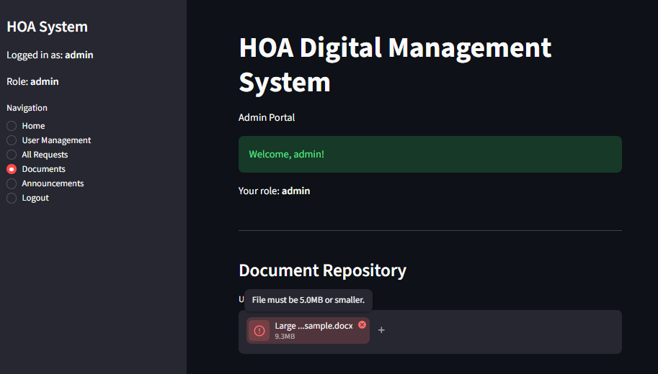
Scenario: File exceeds 5MB limit.
Expected Result: System rejects file, displays size error.
Actual Result: The Uploader turned red with a warning icon. “File must be 5.0MB or smaller.” Status: PASS
Test Case 4.1 — New Version Selected (Before Save) 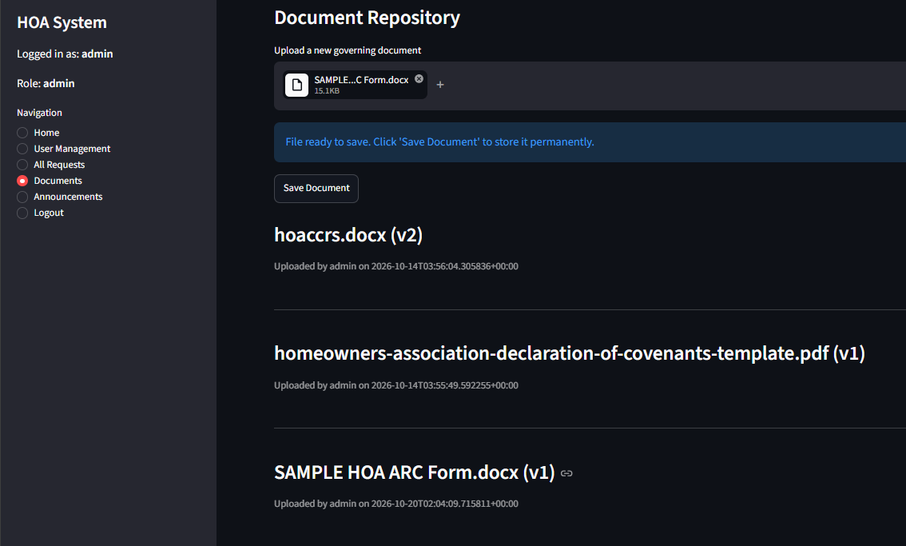
Scenario: Admin uploads file with an existing name.
Expected Result: System identifies existing document and prepares new version.
Actual Result: System displayed “File ready to save...” validating a new version was prepared. Status: PASS
Test Case 4.2 — Successful Save of a New Document Version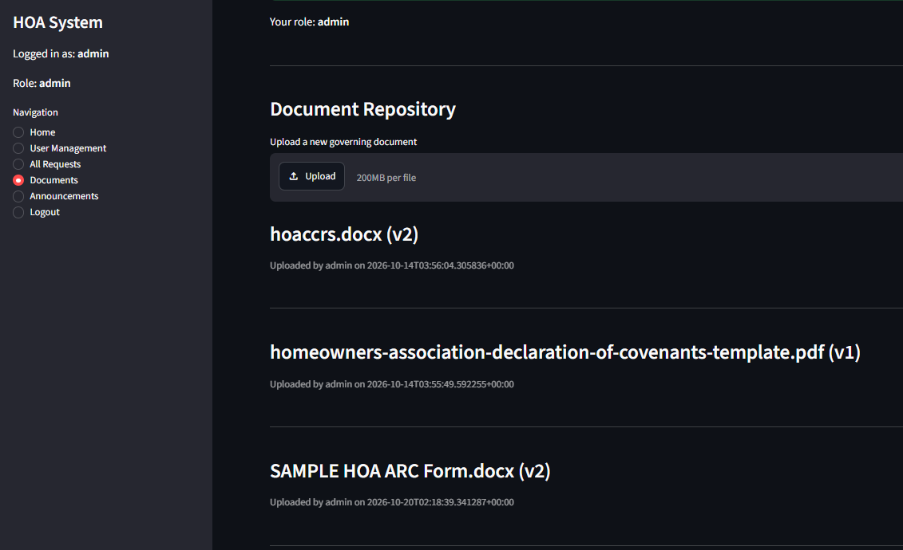
Scenario: Admin saves updated version of existing document.
Expected Result: System increments version number and updates repository.
Actual Result: Document saved as v2; metadata updated.
Status: PASS
Test Case 5 — Document Listing and Metadata Display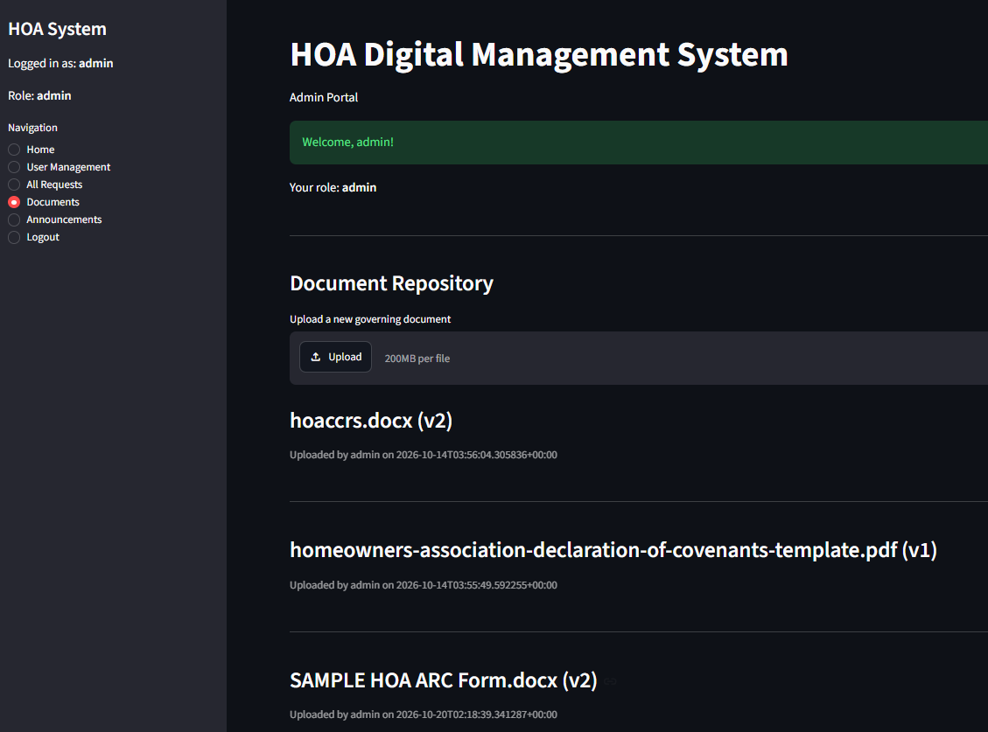
Scenario: Admin views repository.
Expected Result: System displays all documents with version, uploader, and timestamp.
Actual Result: Repository displays complete metadata accurately.
Status: PASS

2. Test Documentation
Test Summary Report
Objectives
The objective of testing was to verify that the HOA Digital Management System performs secure authentication, enforces role-based access, and supports reliable document management, including upload, validation, versioning, and repository display.
Scope
Testing covered the following implemented modules:
- Authentication and role validation
- Document upload and validation
- Document versioning
- Document listing and metadata display
Modules not implemented in the current iteration—such as Issue/Maintenance Requests, Announcements, and extended User Management workflows—were out of scope.
Test Cases and Procedures
Testing included both positive and negative scenarios:
- Valid and invalid login attempts
- Missing required fields
- Uploading valid and invalid document types
- Validation of rejection of oversized files
- Uploading updated versions of existing documents
- Viewing repository metadata
Procedures involved logging in as admin or resident, navigating to the Documents module, performing uploads, observing system messages, and capturing screenshots.
Results
All valid test cases passed:
- Authentication correctly validated credentials
- Valid documents were uploaded successfully
- Version numbers incremented correctly
- Repository metadata displayed accurately
Negative test cases behaved as expected:
- Invalid credentials were rejected
- Unsupported file types were blocked
- Oversized file logic was validated and rejected
Bugs, Issues, and Limitations
Role Coverage
Only admin and resident roles were exercised. Additional roles (e.g., board members) can be tested in future iterations.
Unimplemented Modules
Issue Requests, Announcements, and extended User Management workflows were not part of the Unit 6 implementation and were excluded from testing.
Admin Module Issues Encountered During Testing
1. Upload Field Not Clearing After Save (Intermittent)
During testing of the document upload workflow, the upload field occasionally failed to clear after saving a document. Even after a successful upload, the uploader still displayed the selected file. This behavior was inconsistent and appeared to be related to Streamlit’s widget refresh timing.
Resolution: The issue was mitigated by reorganizing widget placement and ensuring the uploader re-rendered after state updates. Restarting the Streamlit session consistently resolved the issue.
2. Save Document Button Not Appearing (Intermittent)
In some cases, after selecting a valid file, the Save Document button did not appear. The file passed validation, but the button failed to render due to conditional UI refresh behavior.
Resolution: Stabilizing the layout and tying conditional rendering to a consistent state variable resolved the issue. This limitation has been documented for future UI improvements.
3. Intermittent UI Refresh Conflicts
Multiple widgets updating simultaneously caused partial renders (e.g., ellipses “…” appearing). These did not affect backend logic but impacted user experience.
Resolution: Restarting the Streamlit session resolved the issue. Future improvements may include explicit rerun calls or restructuring the upload panel.

Part B: CI/CD Reflection Report
1. Introduction
Continuous Integration (CI) and Continuous Deployment (CD) are foundational practices in modern software engineering. As Sommerville (2016) describes, CI/CD enables teams to deliver software rapidly and reliably, with reduced manual intervention. For this capstone project, CI/CD principles streamlined development of the HOA Digital Management System, improved code quality, and supported iterative enhancements across Units 4–6.
2. Understanding CI/CD and Its Relevance
Continuous Integration (CI)
CI focuses on frequently integrating code changes into a shared repository. Fowler (2006) emphasizes that CI reduces integration conflicts and detects issues early through automated builds and tests.
Continuous Deployment (CD)
CD extends CI by automatically deploying validated code to production or staging environments. According to Google Cloud’s DevOps guidance, CD improves delivery speed and reduces manual deployment errors (Google Cloud, 2023).
Relevance to the HOA Digital Management System
The HOA system benefited from CI/CD in several ways:
- Frequent updates were integrated smoothly.
- Automated checks reduced the risk of breaking core functionality.
- Version control ensured traceability of changes.
- Rapid iteration supported new features such as document versioning.
3. CI/CD Tools and Workflow Used
3.1 GitHub for Version Control
GitHub served as the central repository for all source code. Each commit represented a meaningful change, such as adding modules, refining UI components, or updating validation logic. This aligns with Sommerville’s (2016) emphasis on disciplined version control.
3.2 GitHub Actions (Conceptual Use)
Although we did not implement full automation pipelines, I explored GitHub Actions conceptually as a CI/CD engine that can run tests, linting, and deployments (GitHub, 2023).
3.3 Local Development Workflow
The development workflow followed CI/CD principles:
- Develop locally in VS Code
- Test changes using Streamlit’s live reload
- Commit updates to GitHub
- Review diffs
- Push to repository
This iterative cycle mirrors CI practices by validating each change before integration.
4. Benefits Observed During Implementation
4.1 Early Detection of Issues
Frequent commits and incremental testing helped identify issues such as UI refresh conflicts and conditional rendering failures.
4.2 Improved Code Stability
By integrating changes gradually, the system remained stable throughout development.
4.3 Enhanced Collaboration Potential
CI/CD practices support future collaboration by providing clear commit history and consistent coding standards.
4.4 Streamlined Testing and Deployment
Streamlit’s rapid refresh cycle served as a lightweight CD mechanism, providing immediate visibility into changes.
5. Challenges Encountered
5.1 Streamlit UI Refresh Behavior
Streamlit’s rerun model caused intermittent issues such as upload fields not clearing and buttons not rendering.
5.2 Lack of Full Automation
A fully automated CI/CD pipeline was not implemented due to project scope.
6. Future Improvements
Recommended enhancements include:
- Implementing GitHub Actions for automated testing
- Adding unit tests
- Introducing staging environments
- Automating Streamlit deployment using Docker
- Adding linting and formatting checks
7. Conclusion
Applying CI/CD principles to the HOA Digital Management System significantly improved development efficiency, code stability, and overall software quality. The experience demonstrated the value of CI/CD in modern software engineering and provided a strong foundation for future enhancements and more advanced automation.
References
Fowler, M. (2006). Continuous Integration. https://martinfowler.com/articles/continuousIntegration.html
GitHub. (2023). GitHub Actions Documentation. https://docs.github.com/en/actions
Google Cloud. (2023). DevOps: Continuous Delivery. https://cloud.google.com/architecture/devops/devops-tech-continuous-delivery
Sommerville, I. (2016). Software Engineering (10th ed.). Pearson.

